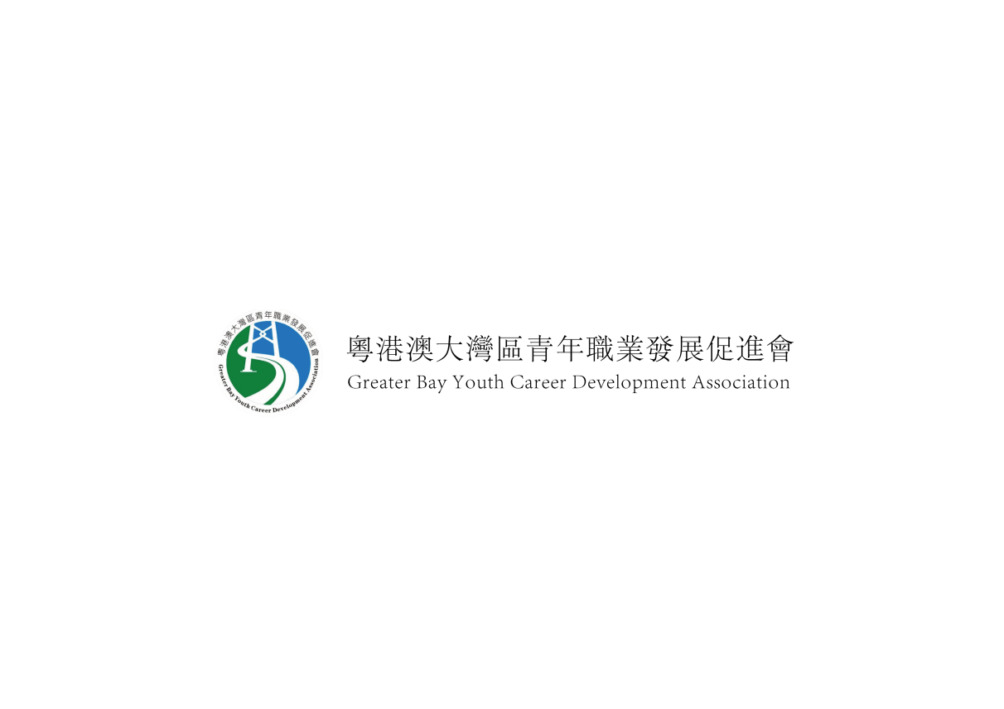
2021-2022 GBYC青年大使報名表申請表（私人及機密）
GREATER BAY YOUTH CAREER DEVELOPMENT ASSOCIATION
YOUNG AMBASSADOR APPLICATION FORM(PRIVATE AND CONFIDENTIAL)

聯繫我們 Contact us:
完成填写后，请将此表发送至E-mail：gbyc.info@gmail.com

稱謂：*先生/小姐：  Title : *Mr/ Ms : | 中文姓名:  Name in Chinese： |  | 英文姓名：  Name in English：姓氏Surname 名Given Name
港澳居民身份證號碼:  HK/Macau Identity Card No./mainland Identity Card No. |  | 是否港澳永久性居民？  Are you a Hong Kong / Macau Permanent Resident?  是/否：
性別： *男 / 女  Sex： *M / F |  | 出生日期：  Date of Birth：DD/MM/YYYY
住宅地址:  Residential Address： |  | 就讀學校/現職公司名稱:  Name of School Attending/Company：
通訊地址 (如與上址不同)：
Correspondence Address (If different from the address given above) ：
住宅電話號碼:  Telephone No.： |  | 就讀年級及科目/職位:  Class Attending and Programme/Job Title：
電郵地址:  Email Address： |  | 學校/公司電話號碼:  School/Company Telephone No.：

